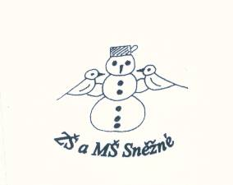



„Podpořme a rozvíjejme čtenářskou gramotnost anglického jazyka prostřednictvím pravidelné práce s anglickými knihami u žáků

na 1. stupni ZŠ.“

The Magic Cooking Pot - roleplay

Narrator: One day, a little girl meets an old woman. The old woman gives her a magic porridge pot.

Old woman: Cook, little pot, cook.

Narrator: And the little pot cooks some porridge. (The pot begins to overflow.)

Old woman: Stop, little pot, stop.

Narrator: And the little pot stops cooking. (The little girl returns home.)

Narrator: The little girl takes the magic porridge pot to her mother.

(The mother stands over the pot.)

Mother: Cook, little pot, cook.

Narrator: And the little pot cooks some porridge.

(The little girl goes out and her mother falls asleep.)

Narrator: Now, there is lots of porridge in the kitchen. But the magic porridge pot cooks and cooks.

(The house begins to fill with porridge.)

Narrator: Now, there is lots of porridge in the house. But the magic porridge pot cooks and cooks.

(The porridge fills the house and flows into the street.)

Narrator: Now, there is lots of porridge in the street. But the magic porridge pot cooks and cooks.

(The porridge fills the town.)

Narrator: Now, there is lots of porridge in the town. But the magic porridge pot cooks and cooks.

(The little girl returns.)

Little girl: Stop, little pot, stop.

Narrator: And the magic porridge pot stops cooking. (The people of the town collect the porridge.)

Narrator: But now the people are eating too much porridge!

The end!