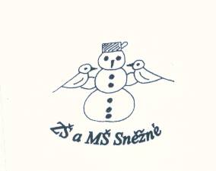

„Podpořme a rozvíjejme čtenářskou gramotnost anglického jazyka prostřednictvím pravidelné práce s anglickými knihami u žáků

na 1. stupni ZŠ.“

**Too fast**

1. Najdi a vypiš slova. / 9slov /

Fastyjehappyjwabikelojnpathndsestophewqrscaredlwlwsdownhrclroadvjsramp

..................................................................................................................................................................................

2. Zakroužkuj správné slovo a věty přelož do češtiny.

The boy is / are Flip. .............................................................................................................................

Some boys / boy are scered of Flip. .......................................................................................................

Flip rides he’s / his skateboard. .............................................................................................................

Max wants to go fast, to / too. ..............................................................................................................

Maxs falls and hits / hit his leg. .............................................................................................................

3. Sestav věty a napiš je.

Ben / in the / and Max / are / park. ......................................................................................................

very / goot at / Max / skateboarding. / isn’t .........................................................................................

his / Max / skateboard. / rides ..............................................................................................................

Max / stop / can’t / the / skateboard. ....................................................................................................

|  |
| --- |
|  |

4. Napiš pět vět o skateboardu a nakresli ho.

........................................................................

........................................................................

........................................................................

.......................................................................

.......................................................................

**Do you like this story? ☺ 😐 ☹**