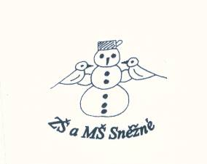

„Podpořme a rozvíjejme čtenářskou gramotnost anglického jazyka prostřednictvím pravidelné práce s anglickými knihami u žáků

na 1. stupni ZŠ.“

The Magic Cooking Pot

1. Draw the pictures. /nakresli obrázky/

|  |  |  |  |  |
| --- | --- | --- | --- | --- |
|  |  |  |  |  |

porridge pot money men woman

2. Write the words. / doplň slova /

|  |
| --- |
| food money hungry girl mother lives |

A little girl ................................... here.

She lives here with her ................................ .

They have no ............................................... .

And they are very ........................................ .

„Oh, mum!“ says the little .................................. . „I am very hungry!“

There is no ................................... in the house.

3. Choose. / vyber správné slovo 🗹 /

The little girl and her mother eat porridge every ...

🞎 morning 🞎 evening 🞎 day

They have a ...................... cooking pot.

🞎 big 🞎 magic 🞎 bad

One day the little girl goes ....................... .

🞎 out 🞎 up 🞎 down

**Do you like this story? ☺ 😐 ☹**