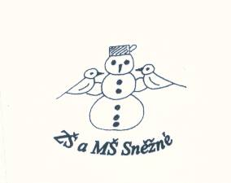

„Podpořme a rozvíjejme čtenářskou gramotnost anglického jazyka prostřednictvím pravidelné práce s anglickými knihami u žáků na 1. stupni základní školy.“

**The Treehouse**

1. Order the words. / sestav ze slov věty /

a treehouse. / and Rosie / Ben / are / making ...........................................................................

is / Clunk / the / big tree. / in / the ............................................................................................

roof. / and the / make / They / the / walls ................................................................................

2. Circle the correct words. / zakroužkuj správné slovo /

Clunk falls on the *trampoline / ground*.

Grandpa comes to the *backyard / forest*.

The children can *climb / play* games in the treehouse.

3. Find and write the words. / najdi a napiš slova /

**Loybackyardensbeetleopisummerqyonestsasfnotebookqwenutsdehammebotsroof**

................................................................................................................................................................

................................................................................................................................................................

4. Put a tick / for yes / or a cross / for no /. / napiš ano či ne podle děje knihy /

Ben, Rosie, Clunk and Max make a treehouse. ...................

They see a parrot on the tree. ...................

The squirrel jumps down to the ground. ...................

Clunk sees a bird on his arm. ...................

Grandpa puts a bell on Bobby’s collar. ...................

**Do you like this story? ☺ 😐 ☹**