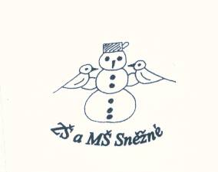

„Podpořme a rozvíjejme čtenářskou gramotnost anglického jazyka prostřednictvím pravidelné práce s anglickými knihami u žáků

na 1. stupni ZŠ“

**The Enormous Turnip**

Narrator: The grandpa goes in the garden, he sees a seed. He puts the seed in the ground.

The seed grows and grows and grows. It is a turnip. The turnip is big, the turnip is very big, the turnip is enormous. The grandpa is happy.

Grandpa: Hello, I am grandpa. I want to eat the turnip. I like it very much.

Narrator: Grandpa pulls the turnip, but the turnip doesn’t move. He sees grandma.

Grandpa: Come and help, please. Pull!

Grandma: Hello, I am grandma. I want to eat the turnip. I like it very much.

Narrator: Grandma pulls grandpa and grandpa pulls the turnip. But the turnip doesn’t move. He sees a girl.

Grandma: Come and help, please. Pull!

Girl: Hello, I am Mary. I want to eat the turnip. I like it very much.

Narrator: Mary pulls grandma, grandma pulls grandpa and grandpa pulls the turnip. But the turnip doesn’t move. He sees a dog.

Girl: Come and help, please. Pull!

Dog: Woof, woof! I am a dog.

Narrator: The dog pulls Mary, Mary pulls grandma, grandma pulls grandpa and grandpa pulls the turnip. But the turnip doesn’t move. He sees a cat.

Dog: Come and help, please. Pull!

Cat: Hello! I am a cat.

Narrator: The cat pulls the dog, the dog pulls Mary, Mary pulls grandma, grandma pulls grandpa and grandpa pulls the turnip. But the turnip doesn’t move. He sees a mouse.

Cat: Come and help, please. Pull!

Mouse: Hello! I am a mouse.

Narrator: The mouse pulls the cat, the cat pulls the dog, the dog pulls Mary, Mary pulls grandma, grandma pulls grandpa and grandpa pulls the turnip.

Narrator: They pull and pull and .... yes!

All: Hooray! We have got the turnip, the enormous turnip! We are happy! Come and eat!

Narrator: They all eat the turnip. It is very good!

That’s the end!