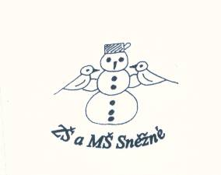

„ Podpořme a rozvíjejme čtenářskou gramotnost anglického jazyka prostřednictvím pravidelné práce s anglickými knihami u žáků na 1. stupni základní školy „

**The Enormous Turnip**

/ pracovní list /

1. **Circle the correct words. /zakroužkujte správné slovo /**

The grandpa / girl pulls the grandma .

The dog / girl pulls the grandma.

The girl / mouse pulls the cat.

The grandma / grandpa pulls the turnip.

1. **Draw the correct pictures. / nakresli správné obrázky /**

The mouse pulls the ................ The cat pulls the ................ The dog pulls the ................ The girl pulls the ............... The grandma pulls the ................ The grandpa pulls the ............... .

1. **Circle, what is vegetables? / zakroužkuj, co je zelenina /**

|  |
| --- |
| Apple Rice Banana Milk Cucumber Onion Carrot  Turnip Bread Pear Pepper  Water Peas Tomato Orange  Potato Butter Egg Kiwi |

1. **Write the words. / napiš slova /**

|  |
| --- |
| pulls eat turnip seed big happy move |

The grandpa puts the ................... in the garden.

The ................... grows and grows.

The turnip is very ............., it‘s enormous.

The girl ............ the grandma.

The turnip doesn’t ................. .

They ............. the turnip.

They are very ............... .

1. **Put the words in the correct order. / dej slova do správného pořadí /**

hungry is grandpa The. ........................................................................................

wants He turnip to eat. ........................................................................................

pulls The grandpa turnip the. .....................................................................

doesn’t move The turnip. .......................................................................................

The sees grandma grandpa. ..........................................................................

help Come and me. .......................................................................................

1. **Draw the story. / nakresli příbeh /**

|  |
| --- |
|  |