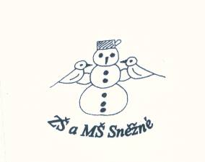

„Podpořme a rozvíjejme čtenářskou gramotnost anglického jazyka prostřednictvím pravidelné práce s anglickými knihami u žáků

na 1. stupni ZŠ“

**Little Red Riding Hood**

/roleplay/

LRRH: I am a little girl, my name is LRRH. I always wear this red hood. I live with my mum.

Mum: IT is your Granny¨s birthday today. Here is a basket. Here is a cake and some wine for her. Také it to the Granny’s house and don’t stop in the forest! A big dangerous wolf is there!

LRRH is leaving home.

Wolf: Iam very hungry.

LRRH: What a beautiful day! Flowers, birds, the sun is shining!

Wolf: Good morning, LRRH. Where are you going?

LRRH: I am going to see my Granny, it is her birthday today.

Wolf: And where does she live?

LRRH: Just behind the forest, not far from here.

Wolf: Ok, bye, bye.

LRRH: Bye.

Wolf runs to the Granny’s house, swallows Granny and gets down to her bed.

LRRH: Good morning, Granny.

Wolf: Good morning, my dear.

LRRH: Oh, Granny, why have you got such big eyes?

Wolf: Because I want to see you well.

LRRH: And Granny, why have you got such a big ears?

Wolf: Because I want to hear you well.

LRRH: And Granny, why have you got such a big mouth?

Wolf: Because I want to eat you well!

The wolf swallows Little Red Ridding Hood. He falls asleep and snores.

There is a hunter near hear.

Hunter: What’s that? Such a horrible snore!

He looks through the window.

Hunter: The wolf!!! And he has got a very big belly! What is inside?

He listens to the belly.

LRRH + Granny: Hepl! Help!

Hunter: Oh, I can hear the voices! Who is It?

The hunter cuts the belly.

LRRH and Granny jump out!

LRRH + Granny: Thank you, brave hunter!

LRRH giving Granny the basket.

LRRH: Happy birthday Granny!

LRRH sings the song to her Granny.

Granny: Thank you, my dear girl.

They eat mum’s cake and they are very happy!